*Jurnal Riset Akuntansi dan Keuangan 12(x) (2024) xxx-xxx*

|  |  |  |
| --- | --- | --- |
|  | Jurnal Riset Akuntansi  dan Keuangan  Journal homepage : <https://ejournal.upi.edu/index.php/JRAK/> |  |
|  |  |  |

# The Effect of Inflation Rate, BI Rate, and Income Per Capita of Indonesia on Spread Based Income of Conventional Banking Sector in 2014-2023

*Florencia Christie 1, Florentina Elena Hermanto 2*, Valerie Angela Kosasih 3,*

*Aulia Nurul 4*

S1 Finance and Banking, School of Business and Economy, Prasetiya Mulya University, Tangerang, Indonesia

*Correspondence: E-mail: [13132110008@student.prasetiyamulya.ac.id](mailto:1313210008@student.prasetiyamulya.ac.id)

|  |  |  |
| --- | --- | --- |
| **ABSTRACT** |  | **INFO ARTIKEL** |
| The banking industry is an important member of Indonesia’s economy as an intermediary that circulates the country’s money. The purpose of this study is to ascertain the effects of certain economic variables, namely, inflation, BI rate, and income per capita towards the banking industry’s main source of income known as spread based income. This study employs time series regression to analyze data collected from Bank Indonesia, Indonesia Banking Statistics, and Statistics Indonesia. The research provided results that indicate a positive yet insignificant relationship between inflation and spread based income, a negative and insignificant relationship between BI rate and spread based income, as well as a negative and significant relationship between income per capita and spread based income. |  | ***Article History:***  *Submitted/Received*  *First Revised*  *Accepted*  *First Available online*  *Publication Date* |
|  | ***Keyword:***  *Inflation, BI rate, Income per capita, Spread based income* |

## 

## 1. INTRODUCTION

The banking industry has a vital role in the growth of Indonesia's economy as a developing country. This is in accordance to Indonesia's laws stated in Undang-Undang No. 10 tahun 1998, the bank is an entity that collects the people's money, whether it be in the form of deposits or non-deposits and redistributes it back as credit to debtors, meaning that the bank is a body of intermediation for the people's money.

The ministry of Finance states that banks earn income to improve their services and activities through spread based income and fee based income. By definition, spread based income is received via funding and lending that places responsibility upon the bank and or debtors to pay interest. It is vital for a bank's management to monitor spread based income as it can be an indicator of efficiency in development of resources and assets as well as the credibility and health of the bank. Such factors will affect the way the bank is perceived by the people in terms of trust and certainty that the bank will fulfill its responsibilities. However, it is no easy task to consistently keep up a high profitability which becomes a challenge for banks every year, thus an adjustment for appropriate management and strategy is needed. Based on Indonesia’s historical data sourced from Indonesia’s banking statistics, the growth of banks’ spread based income is 7.35% in the year 2022 and reaches 16.23% by the end of 2023. Furthermore, a bank’s established Prime Lending Rate (PLR) may change according to internal and external economical situations. A few of these external conditions include inflation, Bank Indonesia’s BI rate otherwise known as BI rate, and income per capita.

Inflation is one of the many economic issues that countries often have to face. As stated by (Caroline & Erick, 2016), inflation is a surge of increasing prices in every sector that may disturb the equilibrium of the flow of cash and products. (Tripuspitorini, 2021) mentions that inflation is prone to change though in a limited fashion. This phenomenon is noticeable when reviewing inflation data from the past 10 years provided by Bank Indonesia (BI), which shows a significant drop from 5.5% inflation in 2022 to 2.86% by 2023. When the value of inflation is high, banks are not willing to provide credit loans to debtors without the necessary risk analysis. The reason being that during times of high inflation, the economy is deteriorating thus increases the possibility for debtors to default. Other than that, study by (Ikhram & Fakhruddin, 2017) provides that inflation affects interest rates positively, denoting that when inflation increases then interest rate will also grow. Consequently, less people are likely to acquire loans as they are more interested in depositing with a higher interest rate. Furthermore, this may generate a higher interest weight owed by the bank, decreasing the amount of spread based income earned.

**H1 : Inflation has a negative effect towards banks’ spread based income.**

BI rate is an interest rate established by Bank Indonesia that is a figurative stance of Indonesia’s monetary policy. So far, BI rate announced by Bank Indonesia’s Board of Governors often fluctuates or experiences change. Starting from 7.75% in 2014 and reaching its lowest point of 3.5% throughout 2021. Fortunately, by 2022 and 2023, BI rate has recovered to a level of 6%. Stated by (Wijaya, 2010) in the book “Analisis Kebijakan Perbankan Nasional,” when BI rate reduces in value, then interest rate set by other banks will follow in the same fashion. A lower interest rate may bring about an increase in demand for loans, as the responsibility placed upon debtors is now set on a smaller scale. Suffice it to say, a decrease in BI rate will theoretically boost bank earnings from spread based income.

**H2 : BI rate has a negative effect towards banks’ spread based income.**

When a client is interested in applying for a loan, they often consider their current financial situation first. People tend to prioritize spending their income on primary needs before fulfilling any secondary or tertiary needs. A classical economic theory proposed by (John Maynard Keynes, 1936) in the book “The General Theory of Employment, Interest, and Money” puts forward that liquidity preference holds speculative motive, implying that people hold money according to its function as a store of wealth. This occurrence is becoming more prevalent as the economy develops and becomes more modern. The higher the income the more prone for speculative motive to be carried out via savings or bank obligation, thus increasing the interest weight owed by banks and reducing spread based income. Needless to say, a client’s income will affect their decision in proportioning cash to be used for speculative motives. According to CEIC data, the amount of income Indonesian citizens earn throughout 2014 to 2023 follows an upward trend. Starting from USD3,369,798 in 2015, reaching USD4,192,769 by 2019, income per capita then reduced to USD3,928,690 through 2020 before peaking at USD4,783,269 in 2022. An increase in people’s earnings will affect their choices towards credit consumption and ultimately have an effect on banks’ spread based income.

**H3 : Income per capita has a negative effect towards banks’ spread based income.**

Previous research by (Simanjuntak, Jontro, Sirait & Josua, 2018) is done to understand the relationship of inflation and interest rate to net interest margin of conventional banks during 2014 to 2016, hailing results that the two variables have an effect on net interest margin however insignificant. This research paper is executed using a different dependent variable, that is spread based income as this paper aims to understand how conventional banks perform specifically from income earned through funding and lending activities. Furthermore, another differentiation would be the implementation of income per capita as an independent variable for it is a factor that may bring effects in the long run as crucial as variables which affect spread based income quickly like inflation and BI rate. Income per capita becomes a variable of consideration in this research as its fluctuations require a longer period of time, thus reflecting development of the country's public welfare.

The timeline chosen for this paper begins from 2014 to 2023, the duration is different from previous research with the primary goal of providing relevant results in a larger time frame. This paper will also focus on the extent of each independent variable’s effect towards spread based income in the form of numbers.

Based on the background of research, the following research problem is formulated : (1) How does inflation affect spread based income of conventional banks during 2014-2023? (2) How does BI rate affect spread based income of conventional banks during 2014-2023?? (3) How does income per capita affect spread based income of conventional banks during 2014-2023?

The purpose of this research is to grasp a betterunderstanding upon the extent of important economic variables effect to spread based income as banks’ main source of earnings (Harmanu, 2018), specifically in the years 2014-2023. The important economic variables mentioned include inflation, BI rate, and Indonesia’s income per capita. With a better grasp of the extent of each economic variable on conventional banks’ spread based income, the author wishes that this paper may give a reference to authorities and management in the banking sector such as central banks, commercial banks and investors to produce an appropriate strategy with the goal of increasing the bank’s profits and ultimately Indonesia's economy. Research with a large time frame is necessary to bring about valid patterns in an economy, especially when income per capita is considered as it provides a better dynamic in the economy when observed in longer periods of time. This research also hopes to provide relevant information regarding the effects of the three independent variables along with economic developments of the past 10 years

## 

## 2. LITERATURE REVIEW

According to previous research, inflation Is denoted to have an insignificant but positive impact on spread based income. Through research done by (Sihombing, 2023), it is concluded that inflation has a positive relationship with interest rate, meaning when inflation increases, interest rate will grow in adjustment to inflation. Such growth may lessen the demand for credit loans and decrease banks’ earnings through credit. This is in accordance to research by (Naibaho, 2018) regarding the correlation between inflation and Non-Performing Loans (NPL) which provides results denoting inflation affects NPL positively and significantly, thus concluding that when inflation increases then the monetary authorities will add the value of interest rates, amplifying the weight of interest that debtors owe which may cause a higher chance for default, resulting NPL to develop in the same manner and spread based income to struggle. However, another research by (Prastowo, 2018) states that inflation has a positive and significant effect on credit distribution in Indonesian general banks, as business owners tend to apply for loans when inflation rises with the goal of capital fulfillment, increasing spread based income.

Based on previous research, BI rate generally has a negative relationship to spread based income. This is due to the pattern that bank interest rates usually follow, that is when BI rate is increased then general banks’ interest rates will be adjusted accordingly to the growth. Even though this relationship is considered insignificant, it may still reduce credit distribution yet increase funding interest, thus affecting spread based income negatively.

Income per capita is considered to increase demand for credit according to previous research. The reason for this is that growing income will also increase the people's ability to fulfill their needs other than the necessities, this pushes citizens to increase their consumption, one such way is through credit consumption. With the growth of credit demand and the reduced risk of a default, spread based income is bound to rise. Different results are reached by (Andhyka, 2018), stating that income affects deposits received by banks positively. This aligns with the theory of speculative motive. With the increase of deposits, the amount of interest weight the bank owes, reducing the amount of spread based income earned by the bank.

## 3. RESEARCH METHODOLOGY

This hypothesis testing is conducted using time series multiple regression with the help of Eviews software for a quantitative explanatory research method. Researchers chose to use this regression because the data used in this study is macroeconomic data which is simultaneously used by Indonesian conventional banks. The data for each variable are collected quarterly from the period 2014 to 2023 and can be continuously applicable throughout the research. Data processing methods in this study involve several interrelated tests, starting from data stationarity tests, ARDL tests, and classical assumptions tests. Data stationarity testing is done through the Augmented-Dickey Fuller Unit Root Test. Meanwhile, the ARDL test can be done if the stationarity test results are at the level and at the first difference. The requirements for performing this analysis include classical assumption tests, which are divided into normality test, multicollinearity test, heteroscedasticity test, and autocorrelation test. The data used in this study is secondary data obtained from official sources, namely Statistik Perbankan Indonesia (SPI) for conventional bank spread-based income data, the Bank Indonesia website, and the Badan Pusat Statistik (BPS) for independent variable data. Based on a review of previous studies and applicable theories, the following is a theoretical framework for the conducted research.

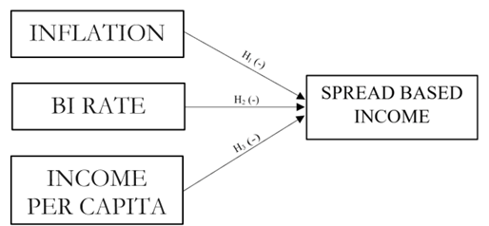

Figure 1. Research Framework

The independent variables in this study are inflation (X1), BI rate (X2), and income per capita (X3) in Indonesia, while the dependent variable used is *spread based income* (Y). The following is a regression equation model formed from this framework .

+ e

$Y$: spread based income as independent variable

$β_{0}$: constant

$β_{1}$: inflation regression coefficient

$β_{2}$: BI Rate regression coefficient

$β_{3 }$: Indonesia’s per capita income regression coefficient

$X_{1}$: inflation rate variable in Indonesia

$X_{2}$: BI Rate variable

$X_{3}$: Indonesia’s per capita income variable in Indonesia

$e$: error

Data collection for this study utilized several official sources accessed via the internet. Inflation and BI rate data were obtained from Bank Indonesia through<https://www.bi.go.id/>. This was followed by Indonesia’s per capita income data, which is obtained from the Badan Pusat Statistik (BPS) Indonesia at<https://www.bps.go.id/>. Lastly, spread-based income data was sourced from Statistik Perbankan Indonesia (SPI) through <https://ojk.go.id/id/kanal/perbankan/data-dan-statistik/statistik-perbankan-indonesia/default.aspx>.

## 4. RESULTS & DISCUSSION

In this analysis, the dependent variable and per capita income data were converted into logarithms to ensure a normal distribution and meet classical assumptions (Hill, Griffiths & Lim, 2018). The data used was transformed into first difference data because the data was proven to be stationary at the first difference level, and to ensure the accuracy of the subsequent test results. The outcomes of classical assumption testing are as follows:

**Tabel 1. Normality Test Result**

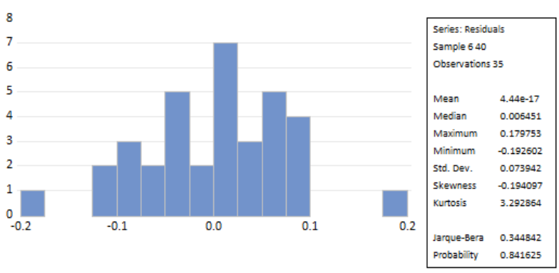

Source : Eviews 12 (2024)

The results of the normality test show an output indicating a probability value of 0.841625, which means the probability value is greater than the critical value of 0.05. Therefore, $H_{1}$ is rejected and it can be concluded that the data is normally distributed.

**Multicollinearity Test**

The next classical assumption test that can be conducted is the multicollinearity test, which aims to see whether there is a linear relationship or correlation between independent variables in the model that has been formed. For this test, the researcher conducted a multicollinearity test using a correlation matrix. According to (Ghozali, Ratmono, 2017), the criteria for the multicollinearity test is that if the correlation value > 0.90, it means that multicollinearity occurs in the data, and conversely, when the correlation value < 0.90, it means that there is no multicollinearity in the data.

**Table 2. Multicollinearity Test Result**

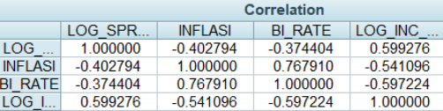

Source : Eviews 12 (2024)

Based on the results of the multicollinearity test using the correlation matrix, it can be seen that the correlation between each variable does not exceed 0.90. Therefore, it can be concluded that there is no multicollinearity in the data used.

**Heteroscedasticity Test**

The heteroscedasticity test using the Breusch-Pagan-Godfrey test aims to test whether there is an inequality of variance of residuals from one observation to another in the regression model. Through this test, it can be determined whether the data is homoscedastic or heteroscedastic. For this reason, the following testing hypotheses are set:

$H_{0}$ = There is no heteroscedasticity (homoscedasticity data) in the data

$H_{1}$ = There is heteroscedasticity in the data

Jika *p-value* < 0.05, *reject $H_{0}$*  and conclude that there is heteroscedasticity in the data.

**Table 3. Heteroscedasticity Test Result**

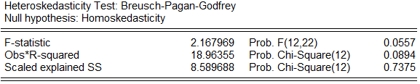

Sumber : Eviews 12 (2024)

The heteroskedasticity test shows that the p-value, as indicated in the Prob. Chi-Square (12) section is 0.0894, which is greater than the critical value of 0.05. Therefore, it can be concluded that there is no heteroskedasticity in the data.

**Autocorrelation Test**

The autocorrelation test conducted using the Breusch-Godfrey Serial Correlation LM aims to determine whether there is an autocorrelation problem in the available data. For this purpose, the following testing hypotheses are set:

$H_{0}$ = There’s no autocorrelation problem in the data

$H_{1}$ = There’s autocorrelation problem in the data

Jika *p-value* > 0.05, *Reject $H_{0}$* and conclude that there’s autocorrelation problem in the data

**Table 4. Autocorrelation Test Result**

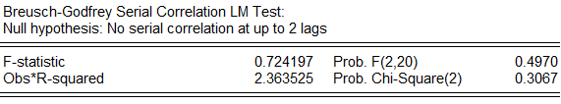

Source : Eviews 12 (2024)

Based on the autocorrelation test, it is concluded that the p-value, found in the Prob. F(2,20) section is 0.4970, which is greater than the critical value of 0.05. Therefore, it can be concluded that there is no autocorrelation in the research data.

**The following are the results of the hypothesis test from the regression analysis conducted:**

**Table 5. Long-run ARDL**

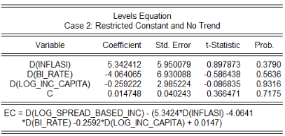

Source : Eviews 12 (2024)

Based on Table 5, the regression equation model can be written as follows:

Y = 0.014748 + 5.342412 X1  4.064065 X2 - 0.259222 X3

*Information* :

Y : spread based income as independent variable

X1 : inflation rate variable in Indonesia

X2 : BI Rate variable

X3 : Indonesia’s per capita income variable in Indonesia

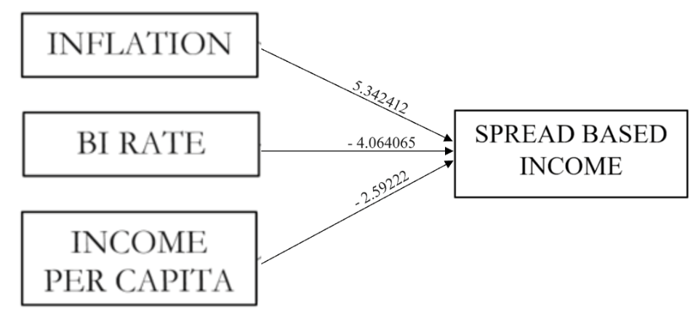

Figure 2. Research Framework

**Table 6. ADF Unit Root Test**

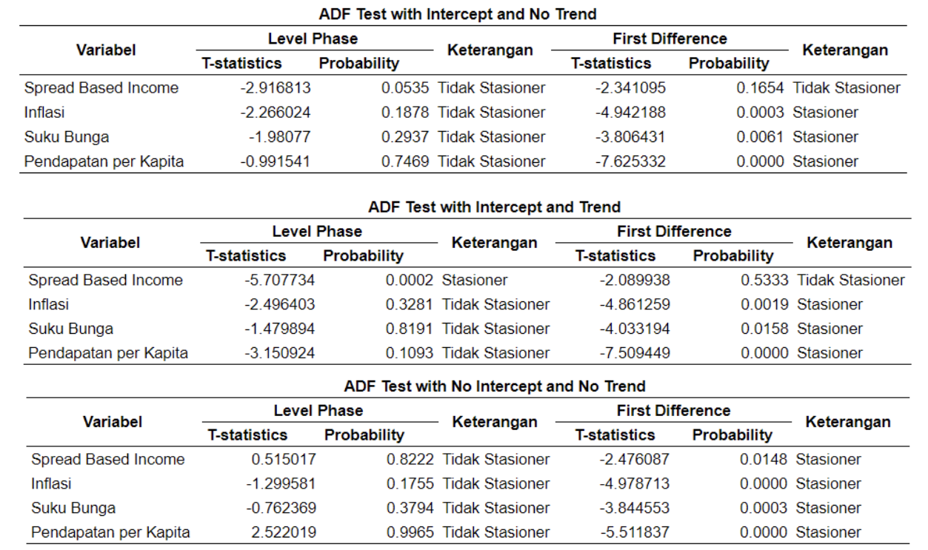

Source : Eviews 12 (2024)

In conducting time series data testing, before performing regression and further tests, it is essential to ensure that all the data used have passed the stationarity test to avoid spurious regression, which results in misleading conclusions. Table 6 shows that at the level phase, only the spread-based income variable is stationary, indicated by the probability being less than the critical value ($α=0.05)$, while all independent variables are proven to be stationary at the first difference level. This result indicates that the data used in the time series regression for this test are mixed stationary. Therefore, the researcher decided to transform the data into first difference data for the subsequent tests.

**Table 7. F-bound Test**

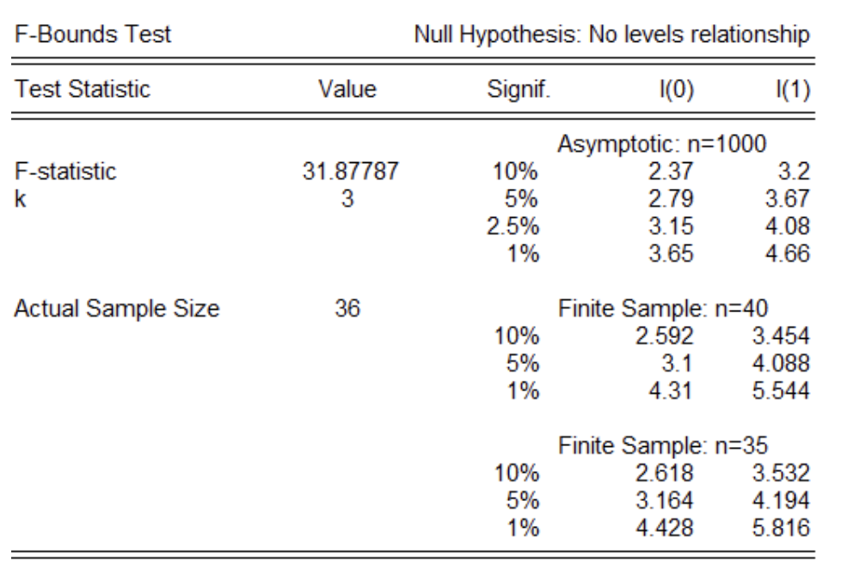

Source : Eviews 12 (2024)

**Table 8. AutoRegressive Distributed Lag (ARDL)**

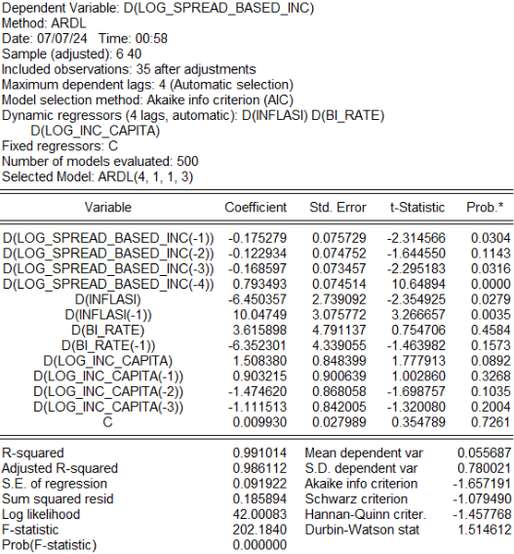

Source : Eviews 12 (2024)

Table 7 shows that there is cointegration in this analysis because the F-Statistic of 31.87787 is greater than the I(1) significance level of 5% and 1%. Furthermore, Table 8, which presents the results of the ARDL regression, indicates a long-term relationship between the independent and dependent variables after ensuring the existence of cointegration in the analysis. In this test, the adjusted R-squared is 0.986112, which is considered normal as the adjusted R-squared for time series data is naturally high. Adjusted R-squared can be interpreted as the level of influence of the dependent variable. Additionally, the F-Statistic with a p-value < 5% significance level indicates that inflation, BI ratw, and per capita income have a significant joint effect on the dependent variable.

Based on Table 8, it can be interpreted that there are independent variables with a p-value < 5% significance level, thus being significant in certain lag periods. This establishes that after a period corresponding to the lag, such as lag (-1) which means after 1 quarter, lag (-2) which means after 2 quarters, and so on, the related independent variables still have an effect on bank spread-based income. In Table 8, it can be seen that inflation at lag 1 has a probability smaller than 0.05, indicating that this variable is significant to spread-based income after 1 quarter and has an effect of 10.04749 according to the coefficient. Similarly, spread-based income at lags 1, 3, and 4 is still significant after 3 months, 9 months, and 12 months, respectively. These results establish a longer-term relationship with the dependent variable.

**Table 9. Error Correction Model (ECM)**

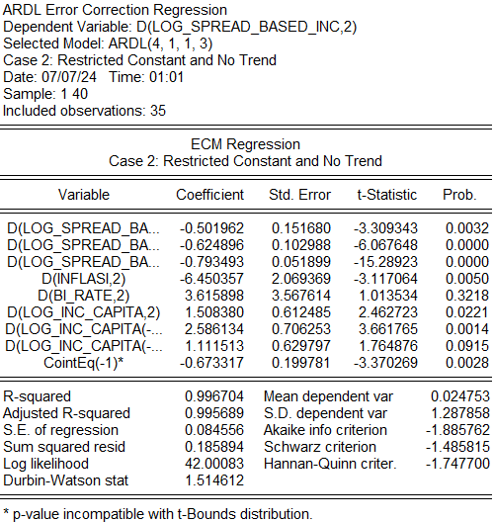

Source: Eviews 12 (2024)

In Table 9, the ECM regression obtains a p-value for the Coint-Eq of < 0.05, specifically 0.0028, with a coefficient of -0.673317. This result indicates that there are short-term deviations from the long-term equilibrium among the variables and it takes approximately 1.48 periods to return to long-term equilibrium. Additionally, the adjusted R-squared of 0.9956 signifies that all dependent variables together have explained the spread-based income

**H1 : Inflation has a negative effect towards banks’ spread based income.**

In Table 5, the coefficient value test shows a result of 5.342412, leading to the reject H1. This result aligns with the previous research conducted by Sa’ad (2015), which explains that inflation has a negative effect on third-party funds because people tend to withdraw their savings. On the other hand, bank credit disbursements increase. Credit and savings taken by customers are intended to meet their consumption needs due to fluctuating prices. This leads to a decrease in the interest burden borne by banks as liabilities to creditors, while interest income from credit increases. Therefore, spread-based income for banks can increase when inflation rises. Hence, from this hypothesis test, the author concludes that inflation has a positive or directly proportional effect on spread-based income. However, with a probability greater than 0.05, it indicates that the independent variable does not have a significant effect on the dependent variable. Therefore, it can be concluded that inflation does not have an impact on spread-based income.

**H2 : BI Rate has a negative effect towards banks’ spread based income.**

Table 5 shows that the coefficient value is -4.06406, therefore, hypothesis two is accepted. The result of this test is in line with the research conducted by (Mukarramah, Zulkarnain, Yolanda, Chaira, & Butar-butar, 2024) which states that when BI rates increase, it has an influence in reducing the interest of debtors, especially entrepreneurs, to take out loans as capital. When BI rates increase, the Prime Lending Rate (PLR), which is the main source of how much interest income a bank can receive, also increases. The increase in PLR is one of the factors that influence customer decision-making because when BI rates are high, the debtor's obligations are also higher, so the demand for credit from customers will decrease. Through this decrease in demand, bank interest income will decrease, while on the other hand, when BI rates increase, it also causes interest on deposits to increase so that customers are more interested in putting their money or money into savings and this causes the bank's interest expense to increase. Therefore, from this hypothesis test, the author obtained results that BI rates have a negative or inversely proportional relationship with spread-based income. However, with a probability greater than 0.05, it indicates that the independent variable does not have a significant effect on the dependent variable. Therefore, it can be concluded that BI rate does not have an impact on spread-based income.

**H3 : Income per capita has a negative effect towards banks’ spread based income.**

Table 5 shows that the coefficient value is -0.259222, therefore, hypothesis three is accepted. When per capita income increases, it indicates an increase in people's welfare, meaning they can meet their daily needs or desired things without having to apply for credit; instead, customers will increase the proportion of money they have for speculative activities such as adding and placing their income in savings and buying securities. This result is in line with previous research conducted by (Ginting, 2019) which states that per capita income has a positive effect on people's savings because not all income owned by people is used to increase consumption but is rather used more for saving. Therefore, through the behavior of customers who prefer to save from speculation rather than applying for loans to meet excessive needs, the interest expense borne by banks from funding activities will increase compared to interest income from loans which is the obligation of debtors, so spread-based income can decrease. Therefore, from this hypothesis test, the author accepts H3 because the results obtained show that per capita income has a negative or inversely proportional relationship with spread-based income. However, with a probability greater than 0.05, it indicates that the independent variable does not have a significant effect on the dependent variable. Therefore, it can be concluded that Indonesia's per capita income does not have an impact on spread-based income.

## 5. CONCLUSION & RECOMMENDATION

The hypothesis tests show that inflation has a positive influence. These results indicate that the development of inflation is in line with spread-based income, as when inflation increases, spread-based income will also increase. Due to inflation does have an effect on considering consumers to withdraw and borrow funds for people's consumption needs when inflation increases, resulting in additional income and a decrease in interest expenses, which causes the bank's spread-based income to increase. However, because the influence provided is not significant, the banking income spread will experience a fairly slow increase when inflation occurs.

BI rate has a negative influence on bank’s spread based income. The PLR level established by the bank influences a customer's decision to take out credit. When the PLR declines, clients are more willing to apply for credit because the amount of interest required decreases in proportion to the PLR. On the other hand, if the PLR increases, the interest that needs to be fulfilled by the customer also increases, causing many potential debtors to move away from credit lending and turn to saving funds. High LPR tends to drive up deposit interest received by customers, which leads to higher bank's interest expenses. This expenditure certainly causes the bank's spread-based income to decrease and shows that shifting to PLR is inversely proportional to spread-based income. However, because the influence provided is not significant, the banking income spread will experience a fairly slow decline when BI Rate increases.

Income per capita has a positive effect on spread-based banking income. When people's income increases, they have the ability to buy the goods they want without needing to apply for credit, and they will even have the desire to save their income in savings or buy securities. Customer behavior will cause the bank's interest expenses from funding activities to increase compared to the credit interest income paid by debtors, which will indirectly cause the spread-based income of conventional banks to decrease. However, because the influence provided is not significant, the banking income spread will experience a fairly slow increase when there is an increase in income per capita.

The aim of this research is to determine the influence of inflation, the BI rate, and income per capita on spread based income. Based on this research, it is suggested that the regression coefficient value for inflation is 6.511937 which shows that every shift in inflation either up or down will affect spread based income by 6.511937 or -6.511937. As same as the regression coefficient value for BI rate is -1.953893, it means the change on BI rate will influence by -1.953893 or 1.953893 based on its increase or decrease. Moreover the coefficient value for income per capita is 1.125709 interpret the amount of influence on spread based income, which will increase or decrease according to the coefficient.

Hopefully, the results of this research will provide a deeper understanding of the subject of the three economic variables on the bank's main income. This research is also expected to provide a broader perspective with a research period that widens the various economic developments that have occurred over that time interval.

In order to improve the accuracy of future research, it is recommended to use data that has been recorded more consistently, such as monthly or daily data. This is also a weakness of this research because the data used is recorded quarterly, which may diminish the accuracy of the results. Furthermore, this study did not take into account the consequences of the COVID-19 pandemic, which lasted from 2019 to 2023, lowering the overall picture of the research results. Future studies should include the economic changes caused by the pandemic.

**REFERENCES**

Andhyka, T. (2018). Analisis Pengaruh Bi Rate, Inflasi Dan Pdrb Perkapita Terhadap

Penghimpunan Dana Pihak Ketiga Pada Bank Umum Di Kabupaten Banyumas Tahun 2008-2015 (Doctoral Dissertation, Iain Purwokerto). Retrieved from <http://repository.uinsaizu.ac.id/id/eprint/3801>

Barus, S. E., & Caroline, A. (2016). Analisis Faktor-Faktor yang Mempengaruhi non

performing loan pada bank Umum di Indonesia. Jurnal Wira Ekonomi Mikroskil, 6(2), 113-122. Retrieved from <https://doi.org/10.55601/jwem.v6i2.325>

Ginting, E. P. (2019). Analisis Pengaruh Pendapatan Per Kapita, Tingkat Suku Bunga, Jumlah

Uang Beredar Dan Inflasi Terhadap Tabungan Di Indonesia. Retrieved from <http://repository.uhn.ac.id/handle/123456789/3027>

Harmanu, A. (2018). *Pengaruh Pendapatan Non Bunga (Non-Interest Income) Terhadap*

*Kinerja Perbankan (Return on Equity) Pada Bank BUKU 4 (Periode Tahun 2015-2017)* (Doctoral dissertation, Universitas Brawijaya). Retrieved from <http://repository.ub.ac.id/id/eprint/174961>

Haryanto, S. B., & Widyarti, E. T. (2017). Analisis Pengaruh NIM, NPL, BOPO, BI Rate dan

CAR terhadap penyaluran kredit bank umum go public periode tahun 2012-2016. *Diponegoro Journal of Management*, *6*(4), 942-952. Retrieved from <https://ejournal3.undip.ac.id/index.php/djom/article/view/18062>

Hill, R. C., Griffiths, W. E., & Lim, G. C. (2018). Principles of econometrics

Ikram, A. D., & Fakhruddin, F. (2017). Hubungan Suku Bunga Kredit Konsumsi Dan Inflasi

Terhadap Penawaran Kredit Konsumsi. *Jurnal Ilmiah Mahasiswa Ekonomi Pembangunan*, *2*(4), 596-606. Retrieved from <https://jim.usk.ac.id/EKP/article/view/5734>

Wijaya, K. (2010). Analisis Kebijakan Perbankan Nasional. Elex Media Komputindo.

Mukarramah, M., Zulkarnain, M., Yolanda, C., Chaira, T. I., & Butar-butar, C. W. N. (2024).

Pengaruh Suku Bunga, Pendapatan Perkapita, Inflasi dan Permintaan Kredit UMKM Di Indonesia. *JOURNAL ECONOMICS AND STRATEGY*, *5*(1), 11-24. Retrieved from <https://doi.org/10.36490/jes.v5i1.1083>

Naibaho, K, Rahayu, Sri, M. (2018). Pengaruh GDP, Inflasi, *BI Rate*, Nilai Tukar Terhadap

Non Performing Loan Bank Umum Konvensional di Indonesia. Retrieved from <https://administrasibisnis.studentjournal.ub.ac.id/index.php/jab/article/view/2678>

Prastowo, P. R., Mardani, R. M., & Wahono, B. (2018). Analisis pengaruh inflasi, suku bunga

dan nilai tukar terhadap profitabilitas perbankan. *E-JRM: Elektronik Jurnal Riset* Manajemen, 7(16). Retrieved from <https://jim.unisma.ac.id/index.php/jrm/article/view/1324>

Puji Astutik, F., & Susilowati Dwi. (2017). Analisis Faktor-Faktor yang Mempengaruhi

Permintaan Kredit Pada Bank-Bank Umum yang Terdaftar di Bursa Efek Indonesia Periode 2011-2015. Retrieved from <https://ejournal.umm.ac.id/index.php/jie/article/view/6156>

Rahayu, S., & Ikhsan, I. (2017). Pengaruh Tingkat Suku Bunga Dan Pendapatan Per Kapita

Terhadap Permintaan Kredit Di Indonesia. Jurnal Ilmiah Mahasiswa Ekonomi Pembangunan, 2(3), 472-480. Retrieved from <https://jim.usk.ac.id/EKP/article/view/5721>

Rizkina, A., & Diana, A. (2023). Pengaruh Tingkat Suku Bunga Dan Inflasi Terhadap Kredit

Konsumsi Di Indonesia. Jurnal Ekonomi dan Kebijakan Publik Indonesia, 10(1), 54-64. Retrieved from <https://doi.org/10.24815/ekapi.v10i1.37461>

Sa’ad, E. (2015). Analisis Pengaruh Suku Bunga Sertifikat Bank Indonesia dan Inflasi

Terhadap Dana Pihak Ketiga dan Penyaluran Kredit serta Dampaknya Kepada Profitabilitas pada Bank Umum (Bachelor's thesis, Jakarta: Fakultas Ekonomi dan Bisnis UIN Syarif Hidayatullah Jakarta). Retrievied from <https://repository.uinjkt.ac.id/dspace/handle/123456789/33161>

Santoso, C. B. (2015). Pengaruh Tingkat Inflasi, Suku Bunga Dan Nilai Tukar Terhadap

Kinerja Keuangan Perusahaan Perbankan Yang Listing di Bursa Efek Indonesia Periode Tahun 2008-2012. *Measurement Jurnal Akuntansi*, *9*(2). Retrieved from <https://www.journal.unrika.ac.id/index.php/measurement/article/view/1018>

Sihombing, S. C., & Sihombing, D. A. (2023). Pengaruh Jumlah Inflasi dan Nilai Tukar

Terhadap Penyaluran Kredit UMKM Melalui Suku Bunga Dasar Kredit. *Jurnal Manajemen Dan Keuangan*, *12*(1), 61-75. Retrieved from <https://doi.org/10.33059/jmk.v12i1.6444>

Simanjuntak, J. (2018). Inflasi dan Suku Bunga Terhadap Net Interest Margin Pada Bank

Konvensional. *Journal of Accounting and Management Innovation*, *2*(2), 161-169. Retrieved from <https://ejournal-medan.uph.edu/jam/article/view/196>

Siwi, J. A., Rumate, V. A., Niode, A. O. (2019). Analisis Pengaruh Tingkat Suku Bunga

Terhadap Permintaan Kredit pada Bank Umum di Indonesia Tahun 2011-2017. Retrieved from <https://ejournal.unsrat.ac.id/index.php/jbie/article/view/22260>

Tripuspitorini, F. A. (2021). Analisis pengaruh inflasi, nilai tukar rupiah, dan BI-rate terhadap

harga Indeks Saham Syariah Indonesia. *Jurnal Maps (Manajemen Perbankan Syariah)*, *4*(2), 112-121. Retrieved from <https://doi.org/10.32627/maps.v4i2.172>

Widyawati, D., & Kusuma, D. R. (2017). Pengaruh Risiko Kredit, Minimalisasi Risiko,

Pertumbuhan Produk Domestik Bruto, Dan Inflasi Terhadap Pendapatan Bunga Bersih Pada Perusahaan Perbankan Yang Terdaftar Di Bursa Efek Indonesia Periode 2013-2016. *Jurnal Fokus Manajemen Bisnis*, *7*(1), 23-35. Retrieved from <https://doi.org/10.12928/fokus.v7i1.1705>

.